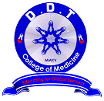 | DDT COLLEGE OF MEDICINE  “Educating for Global Success”  APPLICATION FOR ADMISSION  SCHOOL YEAR_____________
NAME ___________________________ __________________________ _____________________________

(Please Print) LAST FIRST MIDDLE

Postal Address: _____________________________________________ ID NO.__________________ City ____________________________

Tel NO: _______________ Cellphone No.__________________ Date of Birth ________________ Place of Birth _______________________

Age__________ Gender____ __________Citizenship_________________ Marital Status__________ Religion__________________________

E-mail Add________________________________________

Father______________________________ Occupation_________________________ Phone_____________________________

Mother_________________________________ Occupation ________ Phone ___________________________________________

Guardian__________________________ Address____________________________ Phone____________________________________

High School_____________________________________ Year Graduated________________________________

College_______________________________________________________ Year Graduated________________________________

Pre-Med Course________________________________________________ Year Graduated________________________________

School Last Attended______________________________________ School Year ______________________________

What are your B/IGCSE Points? _______________

What is the highest level of education you reached? (e.g.BGCSE, IGSCE, A-levels, BSc year 1 etc.) ______________________
State the grades in the sciences you obtained at this highest level: Double Sciences_____ Chemistry___ Biology____ Physics____
Mathematics _________
What is the value of medical education to you? (Use additional sheet if necessary)

Who would fund your medical education?

How did you know of the DDT college of Medicine?

Which program are you applying for at DDT college of Medicine? Please rank 3 according to importance.

 | Bachelor of Doctors Assistance (BDA) |  | Bachelor of Pharmacy (Pharm) |  | Others (please specify)
 | Bachelor of Medical Laboratory Science (BMLS) |  | Bachelor of Physiotherapy (BPhysio)
(1 = most important; 4 = least important)
Have you applied to other medical school(s)?

[ * ] No [ ] Yes____________________________________________ ________________________________________________

School Status of Application

Have you ever been enrolled in other medical school(s)?
[ * ] No | [ ] Yes___________________________________________ |  | ________________________________________________
 |  | School | Date/School Year
IF FOREIGN APPLICANT: |  | Country ___________________________ | Passport No___________________________________________

IMPORTANT: The application for admission does not mean automatic acceptance to the College of Medicine.

I certify to the veracity of the above information, any evidence of fraud in the credentials/documents submitted will automatically nullify my enrollment in the College of Medicine.

Name.___ ____________ | _____________ _________________
 | Signature of Applicant
I certify further that if accepted, I will abide by all the rules and regulations of the College.

Plot: 1339-41 BBS Mall, P. Box 70587 UB Gaborone, Botswana, Tel No. 390 4925 Cell: 771 00000

E-mail: enquiries@ddtcollegeofmedicine.com or ddtcollegeofmedicine@gmail.com Website: www. ddtcollegeofmedicine.com
ADMISSIONS - AD20172

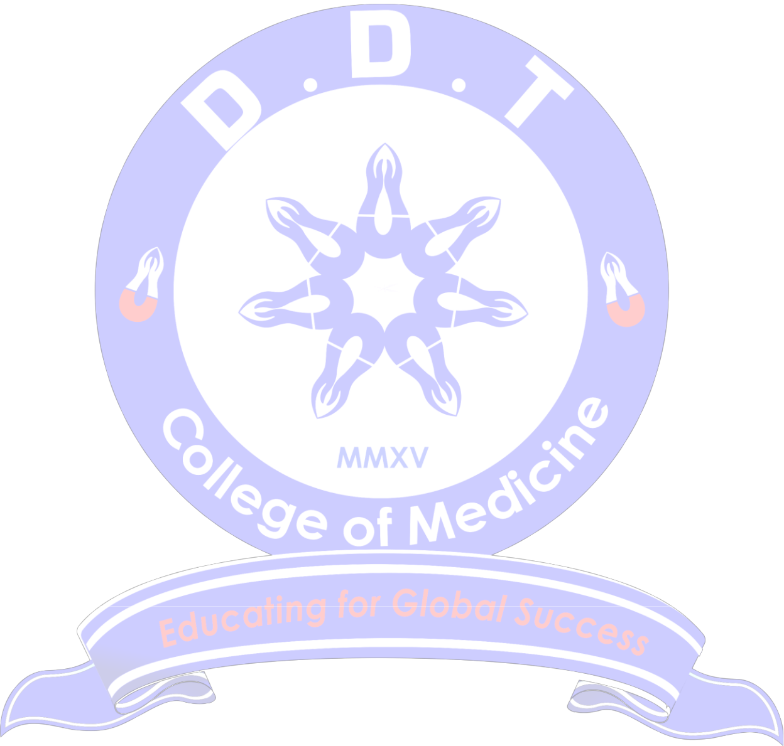
DDT COLLEGE OF MEDICINE

PROSPECTIVE STUDENT RPL ASSESSMENT, ESSAY WRITING AND FEEDBACK (DDTCOM PSAF)

Dear Prospective Student,

We would like to thank you for having participated well in this assessment and essay writing. The College would be most grateful if you could complete this RPL (Recognition of Prior Learning) assessment, essay writing and feedback form.

  - PROSPECTIVE STUDENT ASSESSMENT AND FEEDBACK Circle correctly.

- Have you been hospitalized before with a long illness?

Yes No

If, yes! Briefly explain:

______________________________________________________________________________________

______________________________________________________________________________________

2. Do you have any other health issues that you do need the College to be aware of?

Yes No

If, yes! Briefly explain:

______________________________________________________________________________________

______________________________________________________________________________________

3. | When it comes to technology, are you conversant with the basics of using a computer or a laptop?
 | Yes | No
4. | Can you communicate well in English?
 | Yes | No
 | If, No! Mention where you need help with the language.

______________________________________________________________________________________

______________________________________________________________________________________

- Do you stay with parents/guardian or alone?

______________________________________________________________________________________
- Do you have accomodation in Gaborone you can access/use once admitted by the College?

Yes No

Form AD20172 Page 1 of 3

DDT College of Medicine INTERVIEW ESSAY 2017

Instruction to Applicants: There are 2 essays, you are to answer both:

- ESSAY 1

Explain what led you to pursue being a medical professional and discuss the attributes that make you the ideal candidate for the rigor of DDT College of medicine education. Write this essay below.
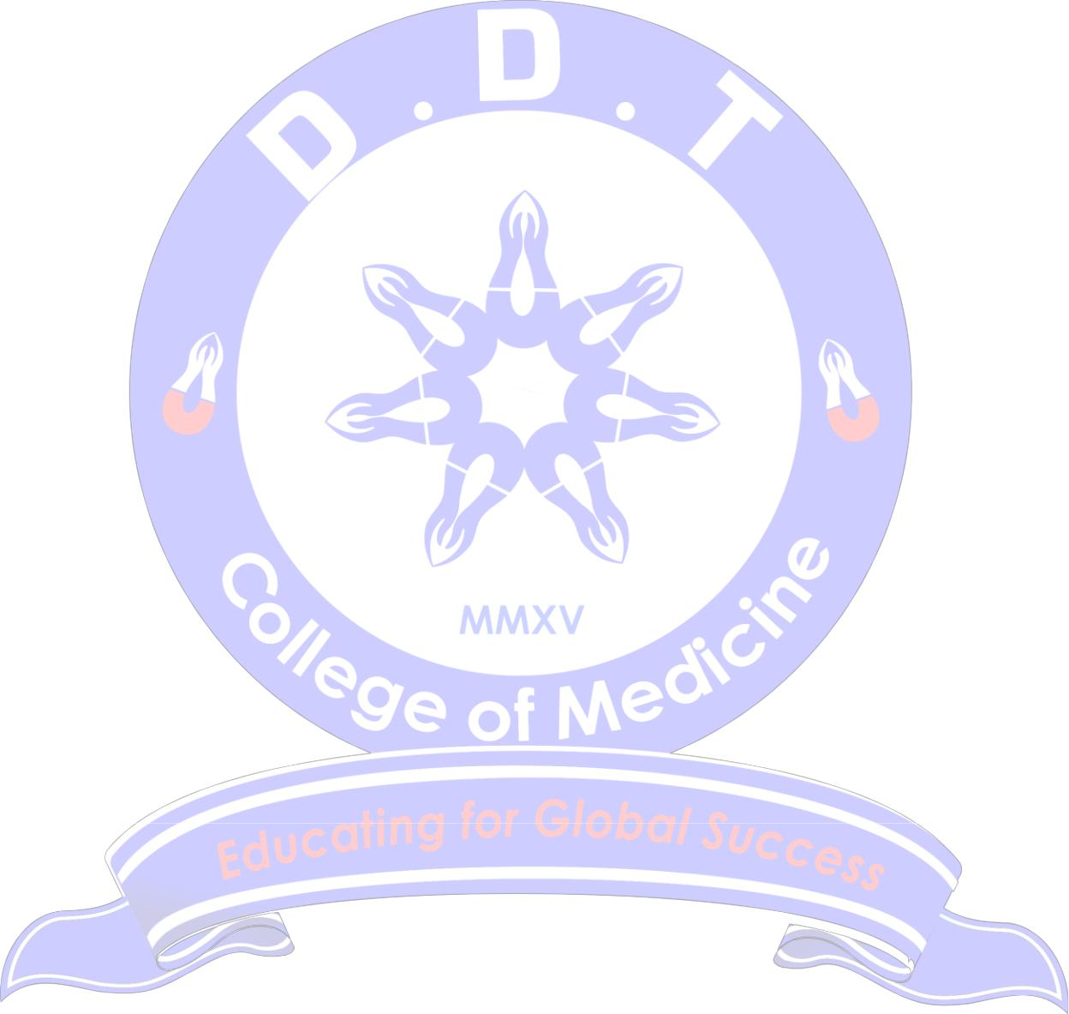

Note: Essay has to be on only one page. Good Luck.

_____________________________________________________________________________________

_____________________________________________________________________________________

_____________________________________________________________________________________

_____________________________________________________________________________________

_____________________________________________________________________________________

_____________________________________________________________________________________

_____________________________________________________________________________________

_____________________________________________________________________________________

_____________________________________________________________________________________

_____________________________________________________________________________________

_____________________________________________________________________________________

_____________________________________________________________________________________

_____________________________________________________________________________________

_____________________________________________________________________________________

_____________________________________________________________________________________

_____________________________________________________________________________________

_____________________________________________________________________________________

_____________________________________________________________________________________

_____________________________________________________________________________________

_____________________________________________________________________________________

_____________________________________________________________________________________

_____________________________________________________________________________________

_____________________________________________________________________________________

_____________________________________________________________________________________

_____________________________________________________________________________________

_____________________________________________________________________________________

_____________________________________________________________________________________

_____________________________________________________________________________________

____________________________________________________________________________________

Form AD20172 Page 2 of 3

- ESSAY 2

There is efflux of medical professionals from Botswana to places all over the world. Discuss if this is acceptable or not and explain how retention of locally trained DDTCOM medical graduates from Botswana can be achieved in a world scrambling for them? Write this essay below.

_____________________________________________________________________________________________

_____________________________________________________________________________________________

_____________________________________________________________________________________________

_____________________________________________________________________________________________

_____________________________________________________________________________________________

_____________________________________________________________________________________________

_____________________________________________________________________________________________

_____________________________________________________________________________________________

_____________________________________________________________________________________________

_____________________________________________________________________________________________

_____________________________________________________________________________________________

_____________________________________________________________________________________________

_____________________________________________________________________________________________

_____________________________________________________________________________________________

_____________________________________________________________________________________________

_____________________________________________________________________________________________

_____________________________________________________________________________________________

_____________________________________________________________________________________________

_____________________________________________________________________________________________

_____________________________________________________________________________________________

_____________________________________________________________________________________________

_____________________________________________________________________________________________

_____________________________________________________________________________________________

_____________________________________________________________________________________________

_____________________________________________________________________________________________

_____________________________________________________________________________________________

_____________________________________________________________________________________________

_____________________________________________________________________________________________

_____________________________________________________________________________________________

_____________________________________________________________________________________________

_____________________________________________________________________________________________

_____________________________________________________________________________________________

_____________________________________________________________________________________________

_____________________________________________________________________________________________

_____________________________________________________________________________________________

_____________________________________________________________________________________________

Form AD20172 Page 3 of 3

